**Introduction:**

The IMF DataMapper is a data tool that allows access to visualize, compare, and download data from a collection of IMF datasets, including a wide selection of regional and country economic indicators.

DataMapper offers an interactive graphical representation of data in the form of a world map, a time-series line chart, and a ranking table which allow users to compare economic indicators by country, region or group. It includes 11 datasets drawn from IMF’s flagship publications – the World Economic Outlook (WEO), the Fiscal Monitor, as well as from other research studies such as the Global Debt Database (GDD) and the Gender Budgeting (GD).

The tool was originally developed in 2007 by Mapping Worlds in collaboration with the IMF. The tool is continuously upgraded, with the most recent upgrade taking place on September 2019. Over the past two years, more than 2.8 million unique visitors used the tool.

**How to use the IMF data mapper**

1. Follow the link: <https://www.imf.org/external/datamapper/datasets>
2. Click on a dataset tile from the 11 listed datasets (For example: World Economic Outlook)

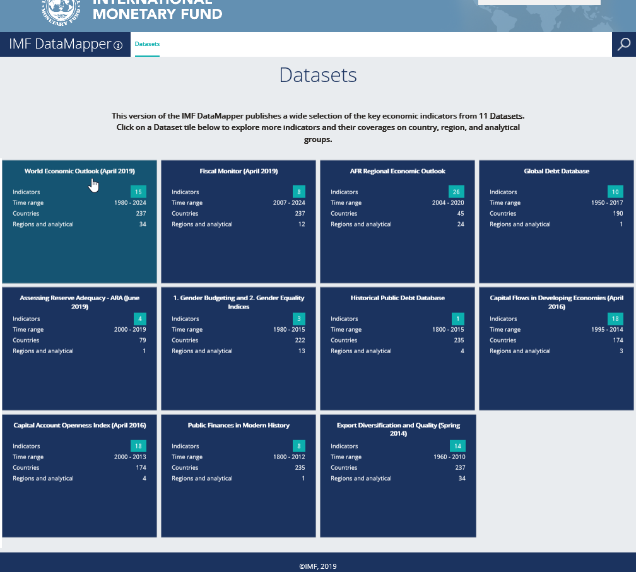

1. Click on an indicator group (For example: Gross Domestic Product - GDP)

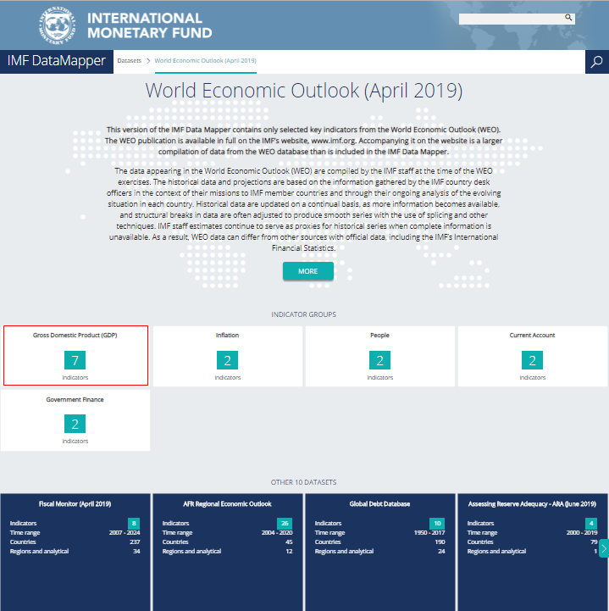

1. Click on an indicator (For example: Real GDP Growth)

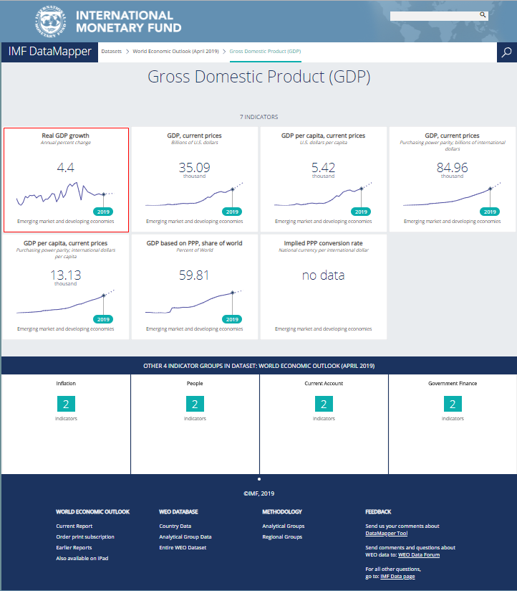

1. Data Mapper view - <https://www.imf.org/external/datamapper/index.php>

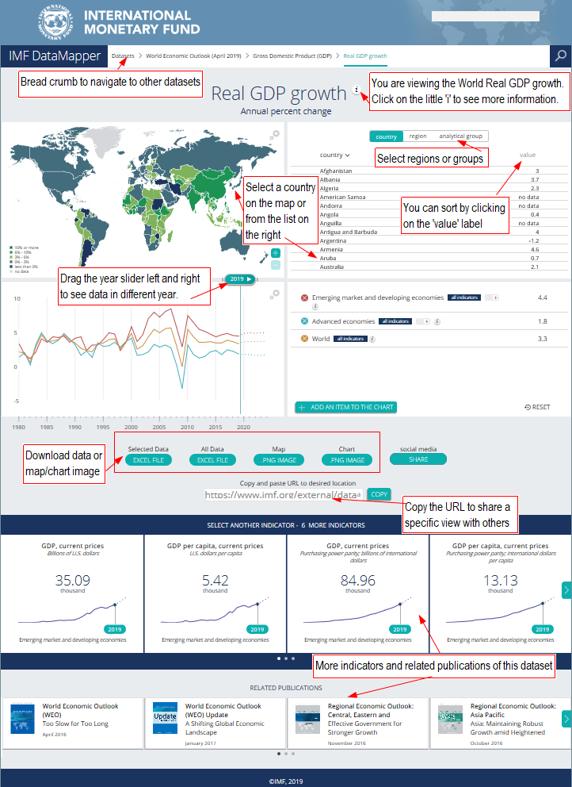

1. Click on a targeted country/ several targeted countries (For example: Japan) from the map. You can also select from the country/region/analytical group list highlighted in yellow

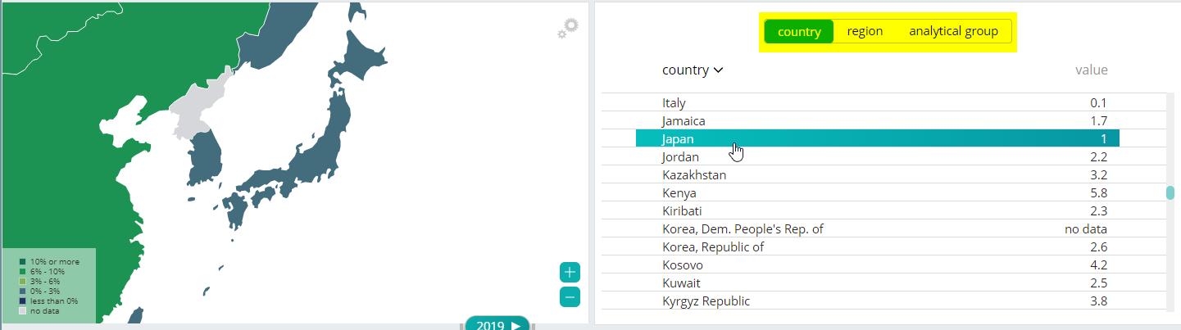

1. Download result in Excel, map or line chart format. You can also share the URL with a specific view with others. Simply click on the ‘Copy’ button next to the text box where it says ‘Copy and paste URL to desired location’

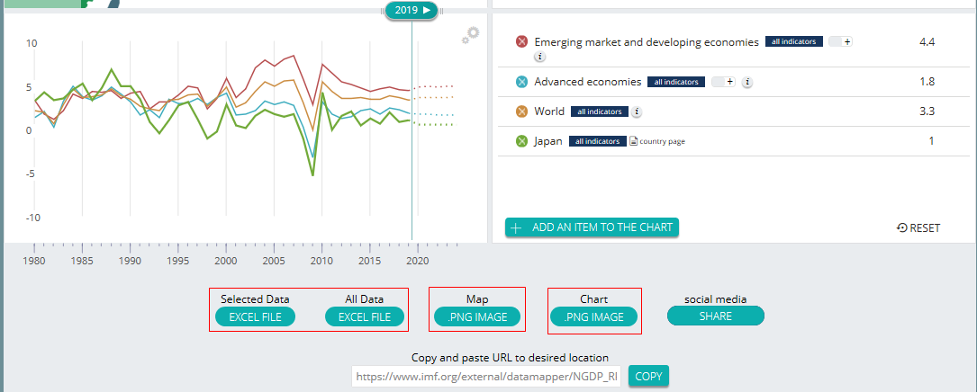

1. Select a country

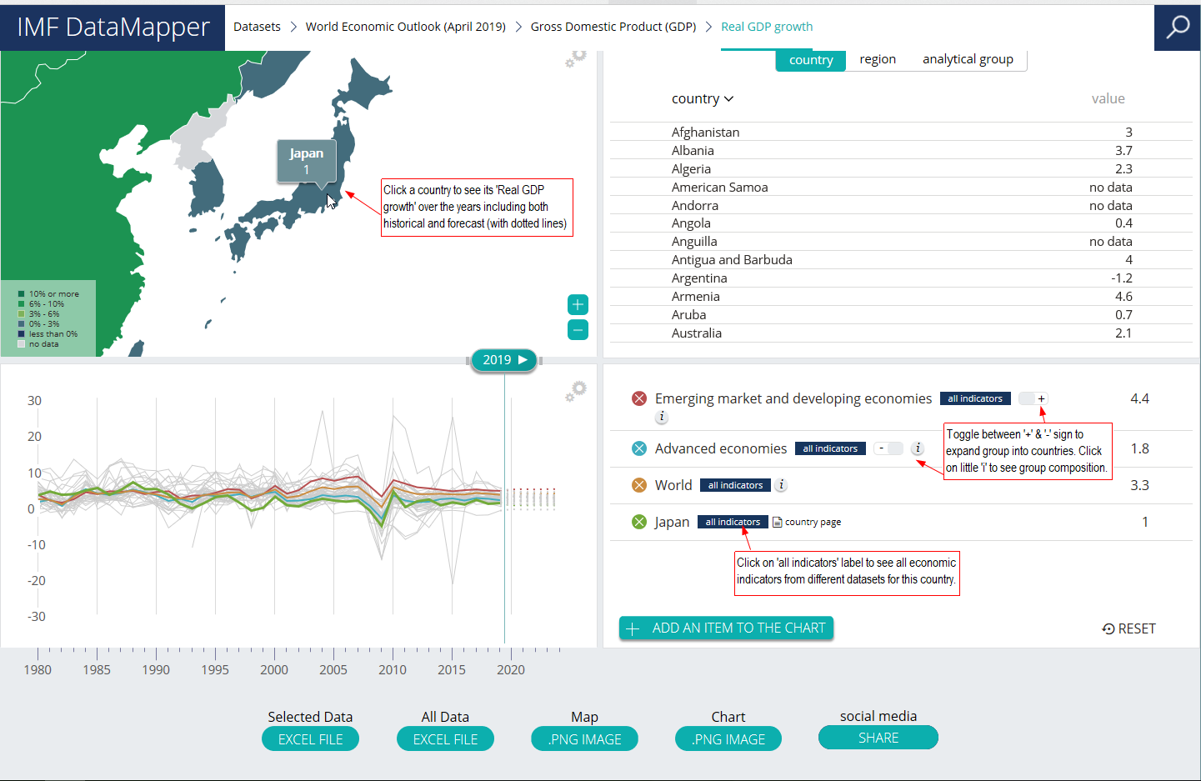

1. Country profile view